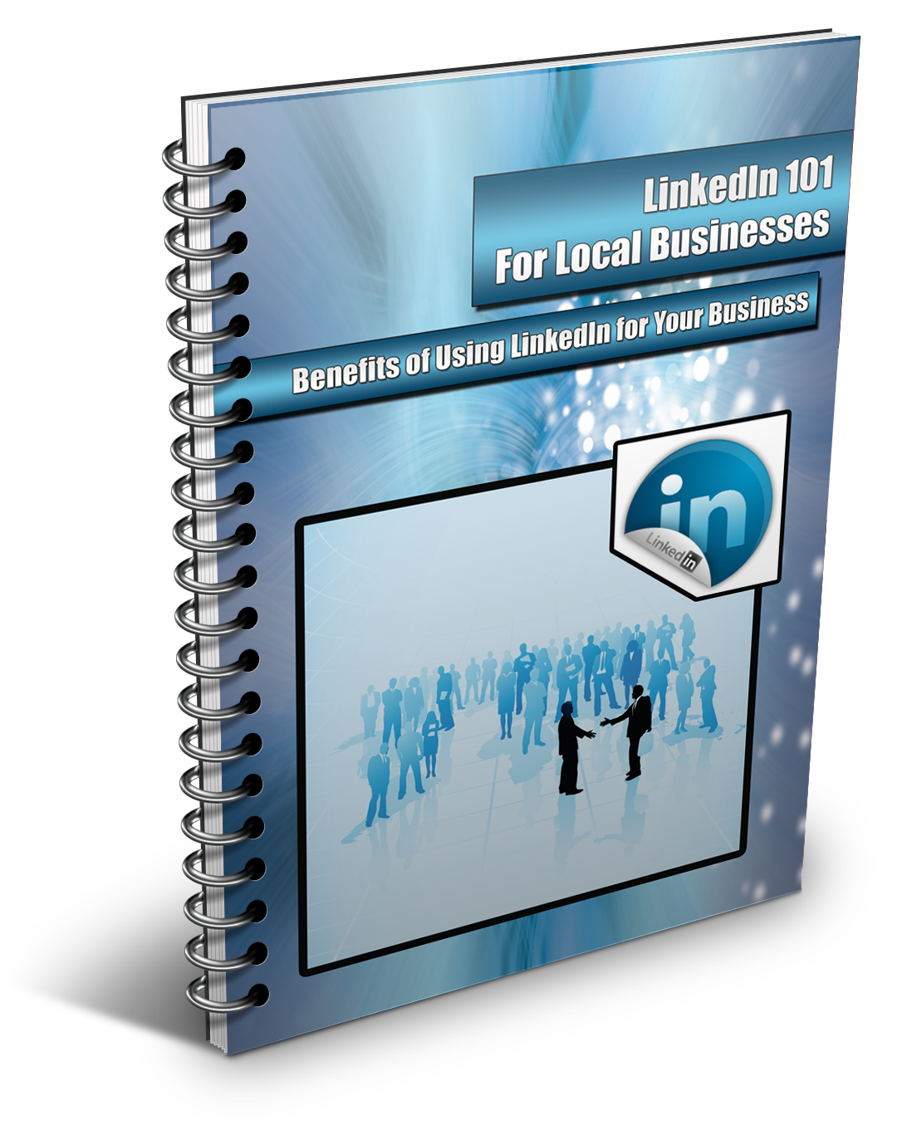

By: Your Name

Your Email Address

Your Phone Number

The Social Media Factor: What is Social Media?
“Social Media” is a red-hot buzz phrase in case you haven’t heard. Everyone is using it including women, men, and children of all ages. Most importantly, your customers are using Social media as well and they expect that your business is in the social loop too.
Social media can be described as information content that is created using new technologies with an aim to facilitate influence, communication, and interaction with the world; including friends, family, peers and customers.
In other words, social media is an advanced way that people can interact using the latest digital technology. Social media networking usually happens through mobile communications networks and the internet, which allow instant access to these platforms.
Social media does not stop at simply publishing information; the real goal is to get people involved. As a local business owner, you want to get reactions and comments from your audience on the information you publish – this is powerful for many reasons. You can look at it as “starting a conversation” on the internet as opposed to “delivering a speech” on the internet.
Social media is perceived as the glue that holds people together in an online community; not only with text, but also images, videos, and other types of online media.
Most people hear “Social Media” and immediately think of Facebook, Google Plus, Twitter, LinkedIn and other social networks of this caliber. These social platforms are the most popular, but this is not the final list by far.
There are a lot of different social media platforms online. Depending on your type of business, you should do some research to see which ones fits your type of business best.
However, using the top four social media sites would be a good start. Chances are, most of your target audience is already logging into these sites every single day.

Social Media Statistics
There are incredible opportunities for small businesses who utilize the power of social media. We will look at actual numbers just to show you how powerful it has become.
As you’ve probably noticed, social media constantly changes year after year. The good news is that people are embracing it and moving right along with it every time it changes. Even people who are 50+ in age are jumping into social media at staggering rates.
Therefore, as a small business owner, most of your customers and prospects are using it, so it’s time to reach them through this amazing marketing channel that is already made for you.
The following statistics will assist you in understanding why social media is important and how you can use it to the advantage of your business’ performance.
The Numbers
The most popular social media sites that you can take advantage of include but not limited to:
- Facebook
- Twitter
- LinkedIn
- Google Plus
2011 was a good year for social media networks; Facebook hit the 800 million users mark with 200 million fans joining in a one-year period. Twitter and LinkedIn both are enjoying over 100 million users.
There are approximately 2 billion internet users in the world and at least 50% of them use social networks.
This shows you just how much social media has taken the internet world by storm. Below are a few quick, but interesting take outs covering social media statistics for the year 2012:
2012 Statistics: Facebook & Twitter Alone
- Facebook, the most popular social media network, has approximately 800+ million users
- The average Facebook user will have a minimum of 130 friends and will like about 80 pages
- On average, 3.5 billion content pieces are shared via Facebook
- Approximately 56% of consumers have reported that they will recommend a certain brand after becoming a fan of the related page.
- Approximately 77% of consumers have admitted that they interact with businesses on Facebook before purchasing their products
- Approximately 50% of Facebook users will log on every single day
- Approximately 55% of users use their mobile phone to access the Twitter platform
- Approximately 34% of business marketers have managed to generate leads using Twitter
General Social Media Statistics
A study by Nielsen shows the following:
- Approximately 80% of Americans use social media networks
- Internet surfers will spend a considerable amount on social networks as compared to other websites
- About 40% of the people will use their mobile phone devices to access social media networks
- Social media fans are more influential and active offline
Experian released a report on the use of social media and these are some of the highlights:
- About 129 million, or 91% of American adult internet surfers, use social media networks every month
- An average Facebook user will spend at least 20 minutes every time they log into their accounts
- Approximately 20% of social media users are more likely to visit other social media sites after they exit from one
The above statistics are more than just mere numbers. They are an actual representation of just how much social media has impacted our daily lives. From these numbers, you can see that one of the best ways to reach out to your prospects and customers, without spending hundreds of thousands of dollars in advertising, is via social media.
Your business can easily communicate with your prospects through social networks and convert them into long-term customers. Your audience can get information on your new products, as well as give feedback on products and services they’ve purchased for you.
It is also a great way to build customer reviews. You should encourage your satisfied customers to go online to social media sites and give a review. Online reviews are instrumental in influencing consumer buying decisions these days. Most people go online to do a little research before they purchase anything.
So it would benefit your business to have a lot of glowing reviews online for everyone to see.
And let’s not forget about Online Reputation Management. Social media allows business owners a way to monitor and respond to what is being said about them online. With a strong social media presence, you will be given a chance to catch and correct any customer service issues that may be made public by an unhappy customer.
With the right approach, local businesses can build a healthy relationship with their customers, as well as with other like-minded companies through the use of social media. In a nutshell, it could be the key to creating more sales and profits funnels into your business.
The number of social media users is projected to increase substantially in 2012 with more than 100 million additional people joining the various networks.
As you can see, when it comes to attracting new customers and prospects, social media must be a part of the plan if you want to grow and expand your local customer reach.
We can no longer look at social media networks only as a thing for the “young generation” to express themselves. We have to look at it as a powerful marketing and advertising vehicle that can take your business to the next level without damaging your wallet.
Let’s take a closer look at one of the most popular social networking sites online today: LinkedIn.

What is LinkedIn?
When most people talk about “Social Media,” they only concentrate on Facebook and Twitter. While these are the biggest social media sites, they are certainly not the only ones doing well. LinkedIn has managed to gather approximately 100 million users and is now one of the most influential social media networks on the internet.
You have probably received an invitation to LinkedIn from a friend or peer over the past few years. Did you accept? Do you even have a LinkedIn account? If not, you are missing out on a huge networking opportunity.
Many local businesses ignore this platform simply because they don’t understand how powerful it can be for exposing and growing their businesses.
LinkedIn is the most popular social networking sites when it comes to online “business networking”. It is a platform that allows business people and professionals all over the world, regardless of their industry, to connect with other professionals.
It is a great environment where individuals connect with multiple like-minded individuals who share interests in the business and professional world. LinkedIn users can even display updates on recent projects and give other users an opportunity to see what they are working on.
The aim of the connection is to share information, market products and services, find jobs, form business-to-business relationships, and much more. LinkedIn is basically free to use, but has premium paid packages that contain more functionality.
LinkedIn works similar to other social networks. You join by simply signing up and then creating a profile which should include any information about yourself that you want to share; such as, employment history, education, achievements, and more. You can then easily link your account to other social network sites, websites and blogs to increase exposure to your profile.

LinkedIn Statistics
Statistics aggregated by Amodiovalerio verde show the following numbers:
- LinkedIn has approximately 147 million members.
- The standard Linked in member is aged 25 to 54 years old.
- 66% of LinkedIn members are located in Europe and N. America.
- LinkedIn’s members have grown by 45% worldwide compared to January 2011.
- Over 40% of members of LinkedIn are employees in companies that employ 10,000+ employees.
Quantcast has the following statistics:
- LinkedIn has more than doubled their monthly visits to 94.3 million in Sept 2011 from 45.8 million in 2010.
- Quantcast breaks down LinkedIn visitors to addicts, regulars and passersby. Addicts account for 1% of members and will use LinkedIn on a daily basis for interaction. Regulars account for 33% of the users and will use the site for interaction more than once but less than 30 times in a period of one month. Passersby accounts for the other 66% and they will visit the site or interact with media only once in a period of one month.
- Approximately 26% of LinkedIn members are between the ages of 18 and 34, while members between the ages of 35 and 50 account for 70% of total members.
- Approximately 75% of members are college graduates and roughly 39% of LinkedIn members earn more than $100,000 every year.

What this Means for Your Business
From these numbers, you can draw a simple conclusion; LinkedIn is an important part of social media that can boost your business if approached properly. LinkedIn is here to stay so you can confidently direct your efforts to improving your business through this powerful social media tool.
Imagine being able to keep track of industry developments and related news just by logging into your LinkedIn account. Connecting with other businesses in your industry can prove to be a very profitable thing. It provides great opportunities in terms of business ventures that would have been missed without it.
For instance, if you run a Fashion Design business, you can connect with groups in this line of business. Doing so will allow you to gain access to a wealth of information as well as connect with other related businesses in that field, such as marketers and distributors who can help expand your company even further.
If you are searching for highly qualified employees, then LinkedIn is one way to find them. LinkedIn is a platform that has a large number of freelancers and job-seekers who possess skills that can take your business to new horizons.
The success of LinkedIn is fueled by the profile you create and how much you reach out to other people.
In other words, social media sites such as Facebook and Twitter are more geared towards “social networking,” while LinkedIn is more geared towards “business connections.”
With multiple opportunities in hand, small business owners have the power to better their businesses using LinkedIn. It is a great marketing tool that is worth learning if you are serious about growing your business.
With so many different social networks on the internet, it may be hard for you to decide which ones you should use. While LinkedIn may not seem important, it could be the missing link you need to take your business to the next level.
Setting up your LinkedIn profile correctly can be somewhat time-consuming and confusing if you’re not familiar with the platform. Not only that, but once it is setup, you have to use it the right way in order to build relationships, which also takes time.
With the help of a trained internet marketing specialist, your LinkedIn profile can be setup thoroughly and quickly. If you would like some professional help establishing a strong presence on this social network, contact me at __________ for a free consultation.

Thank you,
(Your Name)
(Your Phone)
(Your Website)

